Experiment 1

Student Name: Nikhil Kumar UID: 25MCI10036
Branch: MCA (AI/ML) Section/Group: 25MAM-1(A)
Semester: 2-SEM Date of Performance: 07/01/2026
Subject Name: Technical Training - 1 Subject Code: 25CAP-652

- Aim of the Session:

To design and implement a sample database system using DDL, DML, and DCL commands, including database creation, data manipulation, schema modification, and role-based access control to ensure data integrity and secure, read-only access for authorized users.

- Objectives:

After completing this practical, the student will be able to:
- Understand the use of DDL commands to create and modify database structures.
- Perform DML operations such as INSERT, UPDATE, DELETE, and SELECT.
- Implement relationships using primary and foreign keys.
- Apply DCL commands to manage roles and privileges.
- Analyze input and output of SQL queries in a real database environment.

- Practical / Experiment steps:
  - Design the database schema for Department, Employee, and Project tables.
  - Create tables using appropriate constraints.
  - Insert sample records into tables.
  - Perform update and delete operations.
  - Retrieve data using SELECT queries.
  - Create a role and grant/revoke privileges.
  - Alter and drop database objects.

- Procedure of the Experiment:
- Start the system and log in to the computer.
- Open PostgreSQL software.
- Create database exp1.
- Create tables using DDL commands.

Create table Department

CREATE TABLE Department (

dept_id int PRIMARY KEY,

dept_name VARCHAR(50) UNIQUE NOT NULL,

location VARCHAR(50) NOT NULL

);

Create table Employee

CREATE TABLE Employee (

emp_id int PRIMARY KEY,

emp_name VARCHAR(50) NOT NULL,

email VARCHAR(50) UNIQUE NOT NULL,

salary int CHECK (salary > 0),

dept_id int,

CONSTRAINT fk_dept FOREIGN KEY (dept_id)

REFERENCES Department(dept_id) );

Create table Project

CREATE TABLE Project (

project_id int PRIMARY KEY,

project_name VARCHAR(50) NOT NULL,

dept_id int,

CONSTRAINT fk_project_dept FOREIGN KEY (dept_id)

REFERENCES Department(dept_id)

);
- Insert records using DML commands

Insert into Department

INSERT INTO Department VALUES (1, 'HR', 'Mumbai');

INSERT INTO Department VALUES (2, 'IT', 'Pune');

INSERT INTO Department VALUES (3, 'Finance', 'Delhi');

INSERT INTO Department VALUES (4, 'Marketing', 'Bangalore');

INSERT INTO Department VALUES (5, 'Operations', 'Chennai');

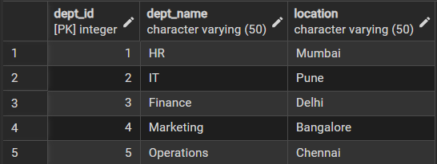

Insert into Employee

INSERT INTO Employee VALUES (101, 'Amit', 'amit@org.com', 40000, 2);

INSERT INTO Employee VALUES (102, 'Neha', 'neha@org.com', 35000, 1);

INSERT INTO Employee VALUES (103, 'Rohit', 'rohit@org.com', 50000, 2);

INSERT INTO Employee VALUES (104, 'Pooja', 'pooja@org.com', 38000, 3);

INSERT INTO Employee VALUES (105, 'Karan', 'karan@org.com', 42000, 4);

INSERT INTO Employee VALUES (106, 'Sneha', 'sneha@org.com', 36000, 5);

INSERT INTO Employee VALUES (107, 'Anjali', 'anjali@org.com', 47000, 2);

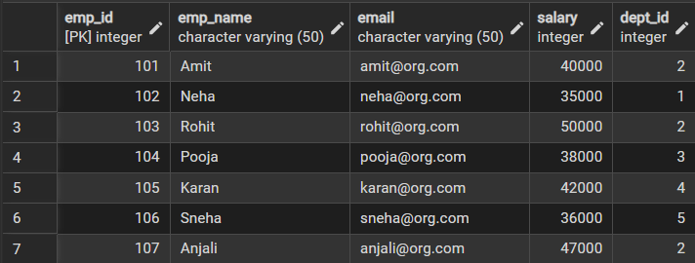

Insert into Project

INSERT INTO Project VALUES (201, 'Payroll System', 1);

INSERT INTO Project VALUES (202, 'Web Portal', 2);

INSERT INTO Project VALUES (203, 'Accounting Software', 3);

INSERT INTO Project VALUES (204, 'Ad Campaign', 4);

INSERT INTO Project VALUES (205, 'Inventory System', 5);

INSERT INTO Project VALUES (206, 'Mobile App', 2);

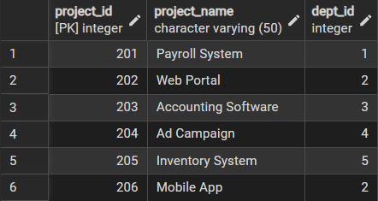

- Update and delete records

UPDATE Employee

SET salary = 45000

WHERE emp_id = 101;

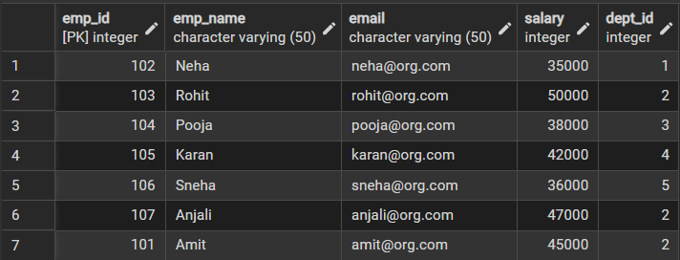

DELETE FROM Project

WHERE project_id = 201;

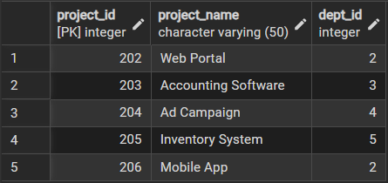
- Create role and assign privileges.

CREATE ROLE report_user LOGIN PASSWORD 'report123';

GRANT CONNECT ON DATABASE exp1 TO report_user;

GRANT USAGE ON SCHEMA public TO report_user;



GRANT SELECT ON Department TO report_user;

GRANT SELECT ON Employee TO report_user;

GRANT SELECT ON Project TO report_user;

REVOKE CREATE ON SCHEMA public FROM report_user;

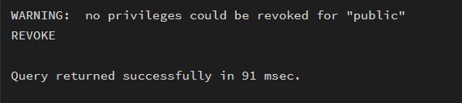
- Alter and drop table.

ALTER TABLE Employee

ADD phone_number VARCHAR(15);

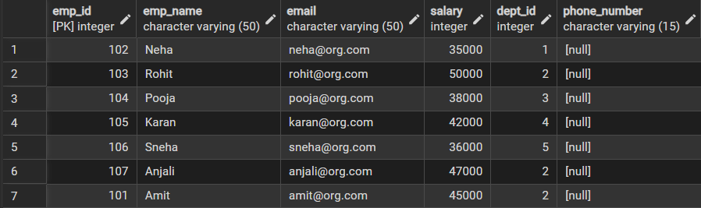

ALTER TABLE Employee

ALTER COLUMN emp_name TYPE VARCHAR(100);

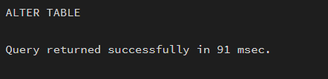

DROP TABLE Project;

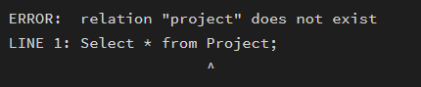
- Learning Outcomes (What I have learned):
- Create database tables using DDL commands with appropriate constraints to ensure data integrity.
- Perform DML operations such as INSERT, UPDATE, and DELETE on database records.
- Establish relationships between tables using PRIMARY KEY and FOREIGN KEY constraints.
- Implement role-based access control using DCL commands to provide secure, read-only access.
- Modify and manage database schemas using ALTER TABLE and DROP TABLE commands.

